SIMATS ENGINEERING (SAVEETHA SCHOOL OF ENGINEERING)
Department of Computer Science and Engineering

ASSESSMENT TOOL 3 – Comparative Analysis

Course Code: | CSA06 | Course Title: | Design and Analysis of Algorithms
CO Assessed: | CO4: Articulation (BL4, BL5) | Assessment: | Assessment Tool 3 – Comparative Analysis
Weightage: | 10% of CIA | Total Marks: | 100
CO4 Statement: | Solve optimization problems using dynamic programming and greedy strategies.
Student Name: | V SANJANA | Reg. No.: | 192571005
Section / Batch: | 2025 | Date: | 192571005

Instructions to Students
- Answer the following question. Total Marks: 100.
- Analyze the given questions thoroughly before answering.
- Compare multiple aspects such as methods, results, advantages, and limitations clearly.
- Critically evaluate the strengths, weaknesses, and implications with proper justification.
- Present meaningful insights, interpretations, and well-supported conclusions from the comparisons.

Question Type | Focus Area | Questions
Comparative Analysis | Comparative analysis of Dynamic Programming and Greedy algorithms for optimization problems. | Q1

SECTION A – Comparative Analysis

Code of Conduct
I _V SANJANA(192571005)_ (Name / Reg No) certify that this submission is my original work and that I have adhered to the guidelines specified for this assessment. I understand that any violation of academic integrity rules will result in disciplinary action.
Signature of the Student: _________________________

RUBRICS FOR CALCULATION

 |  | Comparative Analysis
Criteria | Weightage | Level 4 (Exemplary) | Level 3 (Proficient) | Level 2 (Developing) | Level 1 (Beginning)
Selection of Studies/Parameters | 20% | Selects highly relevant and diverse studies with well-defined comparison parameters | Selects relevant studies with minor gaps in parameter definition | Limited or partially relevant selection | Poor or inappropriate selection of studies
Comparison & Differentiation | 25% | Clearly compares multiple aspects (methods, results, limitations) with strong differentiation | Good comparison with minor gaps | Basic comparison with limited depth | No clear comparison; mostly descriptive
Critical Evaluation | 25% | Critically evaluates strengths, weaknesses, and implications with strong justification | Provides evaluation with some justification | Limited evaluation; lacks depth | No critical evaluation provided
Synthesis & Insight Generation | 20% | Generates meaningful insights and conclusions from comparisons | Some insights derived from comparison | Limited or unclear insights | No insights generated
Clarity | 10% | Information is clearly presented  (tables/figures) with logical structure | Generally clear with minor issues | Presentation lacks clarity or structure | Poor presentation and  difficult to understand

Marks Evaluation:
Criteria | Wt. | Level 4 –  Exemplary | Level 3 –  Proficient | Level 2 –  Developing | Level 1 –  Beginning
Selection of Studies/Parameters | 20%
Comparison & Differentiation | 25%
Critical Evaluation | 25%
Synthesis & Insight Generation | 20%
Clarity | 10%
Total Marks (100):

Faculty In-charge | Course Coordinator | Head of Department
Name: | Name: | Name:
Signature: _______________ | Signature: _______________ | Signature: _______________
Date: ___________________ | Date: ___________________ | Date: ___________________

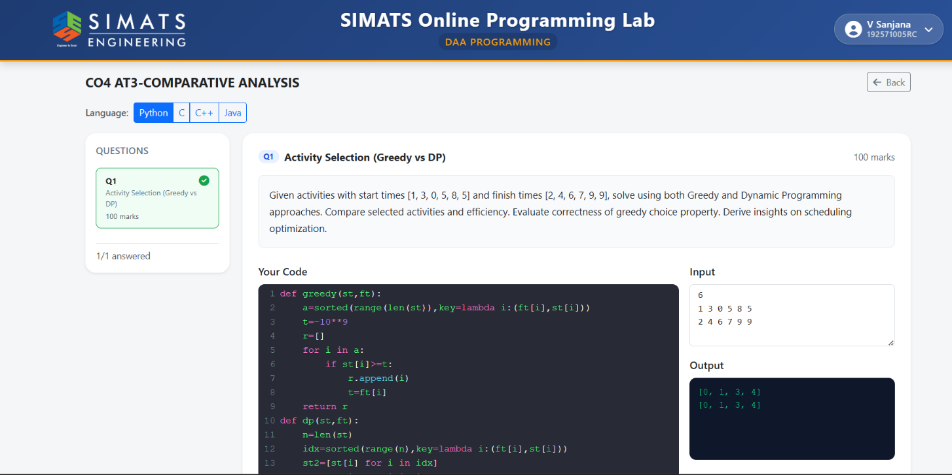

Activity Selection Using Greedy and Dynamic Programming
Problem Statement
Given a set of activities with their start times and finish times, select the maximum number of non-overlapping activities.
Start Times:
[1, 3, 0, 5, 8, 5]
Finish Times:
[2, 4, 6, 7, 9, 9]
The problem is solved using both:
- Greedy Approach
- Dynamic Programming Approach
The selected activities, efficiency, and correctness of the greedy choice are compared.

Greedy vs Dynamic Programming
Feature | Greedy | Dynamic Programming
Main Idea | Select earliest finishing activity | Include/exclude each activity
Selected Activities | A1, A2, A4, A5 | A1, A2, A4, A5
Maximum Activities | 4 | 4
Basic Time Complexity | O(n log n) | O(n²)
Optimized Complexity | O(n log n) | O(n log n)
Space Complexity | O(1) auxiliary | O(n)
Implementation | Simple | Comparatively complex

Greedy Time Complexity: O(n log n)
Greedy Auxiliary Space: O(1)
DP Time Complexity: O(n²) using simple predecessor search
DP Space Complexity: O(n)
The Greedy method selects activities according to their earliest finishing time.The activities are first arranged in increasing order of finish time.The first activity is selected. After that, an activity is selected only if its start time is greater than or equal to the finish time of the previously selected activity.

